Standard Operating Procedure

Rotary Evaporation (Rotovap)
Department:
Completion Date:
Approval (by PI / Lab Manger) Date:
Principal Investigator:
Principal Investigator Signature:
Internal Lab Safety Coordinator/Lab Manager:
Lab Phone:
Office Phone:
Emergency Contact: | (Name and Phone Number)
Location(s) covered by this SOP: | (Building/Room Number)
Type of SOP: ☐ Process ☐Hazardous Chemical ☐ Experiment ☐Equipment Use
Contents

Purpose and Scope
Responsibility
Definitions
Common Hazards
Hazard Control
Location of nearest emergency safety equipment
Step-by-step Operating Procedure
Special handling procedures, transport, and storage requirements
Preventive Maintenance
Monitoring and Safety Systems
Waste Disposal/Cleanup
Emergency Response Plan Procedure
References
Preventive maintenance
Monitoring and Safety Systems
Emergency Response Plan
References
Additional Notes and Attachments
Documentation of Training
Read and review any applicable manufacturer/vendor safety information before developing standard operating procedure and performing work
*** NOTE: Each section needs to be complete with clear and detailed information based on the blue/italic font instruction. SOP must be approved and dated by the PI or lab supervisor.
- Purpose and Scope of Work/Activity:
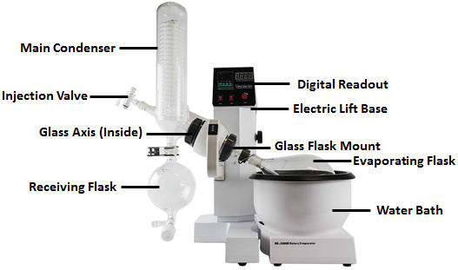
The process of removing a volatile solvent from a non-volatile sample is essential to many laboratories. A rotary evaporator (rotovap) is a fast and effective method of removing solvent from a flask. A rotovap removes solvent by reducing the pressure within the flask using a vacuum, rotating the sample to increase its effective surface area, and heating the solution.
The steps outlined below address general laboratory safety concerns while operating a rotovap. Modify this SOP with your laboratory’s specific operational procedures with the help of the Principal Investigator and verify the SOP with EH&S prior to working with a rotovap. Ensure that the laboratory specific procedures outlined in this SOP are followed by laboratory workers at all times. This document is not designed to substitute hands-on training and supervision by experienced laboratory personnel.
- Responsibility
Identify the personnel that have primary roles in the SOP and describe how their responsibilities relate to this SOP. If necessary, include contact information.
Principle Investigator
- Must provide their laboratory with a copy of this SOP, must sign this SOP, and ensure that all members of their laboratory sign this SOP
- Must ensure that laboratory personnel have obtained the appropriate general laboratory safety training, laboratory specific training and any refresher training
- Must ensure that trained personal conduct repair and maintenance on the equipment as needed
Laboratory Personal
- Must obtain all necessary laboratory safety training, refresher training, and laboratory specific training
- Must read, sign, and follow this SOP when using the rotary evaporator
- Must read the SDS for any compound that is being used as a solvent or sample

- Definitions
In this section, define any additional acronyms or abbreviations that are used in the procedure.
Rotovap: Rotary Evaporation (Rotovap)
SOP: Standard Operating Procedure
SDS: Safety Data Sheets
- Common Hazards
4.1. Chemical Hazards
The chemical hazards involved in rotary evaporation are highly depend on the experiment and can include health hazards, flammables, carcinogens, corrosives, as well as other hazards. Read the SDS for any compounds that will be used with a rotovap and take all necessary safety precautions.
NEVER use a rotovap to concentrate a solution that may contain explosive peroxides or produce explosive peroxides upon concentration. For example, ethers (glyme, THF, diethyl ether, dioxane) can form explosive peroxides when exposed to air, stored for an extended period of time, or upon concertation.
Never isolate peroxides, azides, acetylides, nitro-containing compounds, molecules with strain energy, or thermally unstable compounds using a rotovap, this can lead to a fire or explosion
List all of the specific chemicals typically used and their hazards. Hexane has been provided as an example.
Chemical/Material (Name, Cas #, other ID) | Hazards | GHS Symbol
Health Hazard | Flame | Exclamation Mark
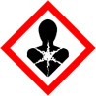 | 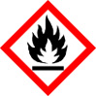
Gas Cyliner | Corrosion | Exploding Bomb
Flame Over Circle | Environment | Skull and Crossbones
 | 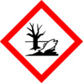

Example: Hexane (110-54-3) | -Highly flammable  -May be fatal if swallowed or enters airways  -Irritant  -Reproductive Toxin  -Toxic to aquatic life

4.2. Hazards and Controls
In general the main hazards and controls associated with Rotary Evaporation are:
Risks and Hazards | Controls
Vacuum/Reduced pressure  - Implosion | - Ensure that there are no star cracks, chips, or defects in the glassware  - Always keep the rotovap in the fume hood with the sash down  - More permanent exterior glass parts (e.g., solvent trap, condenser) should be Plexiglas coated, mesh encased, or taped with electrical tape (pictured below).  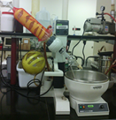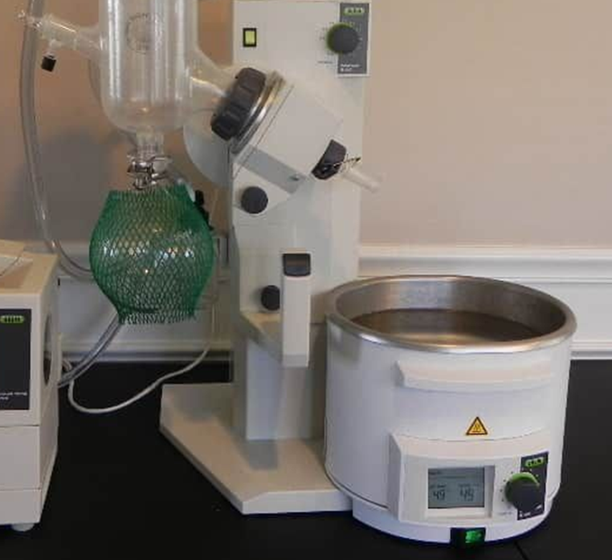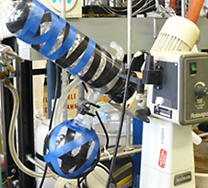
Hot water bath  - Burns  - Electrical heating  - Buildup of residues or bacteria colonies | - Do not touch the hot water bath or the flask that has been in the hot water bath  - Make sure that the water bath never goes dry and do not leave it on for extended periods without supervision  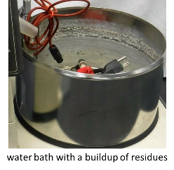  - Always fill the water bath with DI water to prevent the buildup of residues.  - Residues are difficult to remove and decrease the efficiency of the water bath.  - Change the water regularly to prevent the buildup of bacteria colonies.
Cold bath  - Cryogenic burns or frost bite | - Only use vessels that are rated for extreme cold when using a cold bath.  - Use cryogenic gloves when handling the cold bath  - Filled dewars and cold fingers should be secured and clamped within a clutter-free fume hood with the sash down
Rotating equipment  - Pinch hazard  - Loose articles can be caught in the system | - Always secure all loose hair, articles of clothing, jewelry, etc.  - Always turn the rotovap off before adjusting the equipment
Health hazards  - Chemical exposure/inhalation | - Keep the rotovap in the fume hood to prevent inhalation  - Always wear the appropriate PPE
Flammable chemicals  - Fire | - Remove any sources of ignition and combustible materials  - Know the location of all emergency equipment (fire extinguisher, safety shower, etc.)  - Always wear the appropriate PPE
Chemicals can become unstable or explosive when being concentrated  - Explosion  - Violent reaction | - Never isolate peroxides, azides, acetylides, nitro-containing compounds, molecules with strain energy, or thermally unstable compounds using a rotovap, this can lead to a fire or explosion  - Ensure the sample is not reactive or explosive upon concentration  - Never use a rotovap to isolate a solution which produces explosive impurities during evaporation (e.g., ethereal solvents can produce peroxides)  - For peroxide forming solvents that might be exposed to air over an extended period of time - peroxide tests must be conducted
Condensed oxygen  - Explosion | - Never use liquid nitrogen for the cold trap  - Dry ice/acetone baths are sufficient for most applications  - Do not leave the cold finger to condense overnight
Water cooled condenser  - Flooding | - Use a water circulator (never use single-pass cooling) and properly secure all hoses
Air/water reactive reagents  - Violent reaction | - Extra caution must also be applied to operations with air and/or water reactive materials. A leak can draw air into the apparatus and a violent reaction can occur.
Broken glassware  - Laceration | - Make sure to clamp all flasks and joints, this will ensure that the glassware does not fall and break.  - Glass parts (e.g., solvent trap) should be Plexiglas coated, mesh encased, or taped with electrical tape
- Hazard Control(s)
5.1. Engineering/Ventilation Controls
If possible, a rotary evaporator should be used inside a fume hood. This will prevent harmful vapors from being released into the laboratory.
5.2. Administrative Controls
- Documentation
  - Standard operating procedure (SOP) must be completed and signed by every member of the laboratory
  - Safety data sheets (SDS) for each material should be reviewed prior to use
  - Manufacturer operating manual should be reviewed prior to use
- Training
  - Training must be completed prior to working in the laboratory
  - Process specific training must be completed prior to working with a rotary evaporator
  - Basic mandatory trainings must be completed including laboratory safety fundamentals, hazardous waste management, and hazardous materials incidents emergency procedures

5.3. Personal Protective Equipment
EYE PROTECTION: Safety glasses or goggles (if desired face shield over safety glasses).
PROTECTIVE CLOTHING: Flame resistance lab coat (if using flammable chemicals, if not wear a chemical resistant lab coat) and appropriate chemical resistant gloves. Cryogenic gloves should be worn when handling the cold bath.
APPROPRIATE CLOTHING must be worn under the lab coat: long pants, closed-toed/heeled shoes.
- Location of nearest emergency safety equipment
Items | Location
Eyewash/Safety Shower
Chemical Spill kit
First aid kit
Fire extinguisher
Telephone
Fire alarm manual pull station
Others/Details:

- Step-by-step Operating Procedure
Provide the steps required to perform this procedure.
For a process: Write enough detailed description of the procedure to guide the user through the process including details of startup, normal condition operation, temporary operation condition and emergency shut-down, etc.
Also cover enough information as following:
- Chemical concentrations, gas amount
- Pressure limits, temperature ranges
- Flow rates
- Special safety equipment is to be utilized.
- Schematics or pictures for complex setups.
- Highlight safety precautions put in place
- What to do when an upset condition occurs
- What alarms and instruments are pertinent if an upset condition occurs
- If lockout/tagout is required
Some tips:
- Use numbers for steps and sub-steps that have to be performed in a specific sequence
- Use bullets for steps or items that can be performed in any order.
- Solicit ideas for other users.
- Include a flow diagram to help interpret more complex procedures.
- Include pictures and label different components.
For Equipment: Describe the step-by-step procedure for using the equipment properly. Include details for potential equipment failure if something is done improperly in the procedure. Describe how to power down the equipment at the end of use.
A basic procedure is supplied for you below, make sure to include a procedure for your specific instrument and process.
BASIC OPERATING PROCEDURE
- Read the SDS for all materials
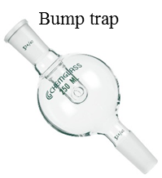
- Inspect the rotovap and all pieces of glassware to ensure that there are no cracks, chips, or defects.
- Make sure that the solvent trap and bump trap are empty and clean
- Fill the hot water bath with DI water if not already filled.
- Fill the cold trap (e.g., dry ice/acetone)
- Cool the receiving flask
  - It is a good idea to cool the receiving flask (e.x. solvent reservoir); it prevents any solvent from evaporating from the receiving flask, especially for low boiling solvents (e.g. pentane).
- Connect the bump trap to the rotovap and secure with the metal clip or a keck clip depending on the model of rotovap (pictured below). The bump trap should be kept clean, it provides a receptacle in case the solution splashes or boils beyond the flask. A clean bump trap can allow for recovery of any solution that “bumps”.
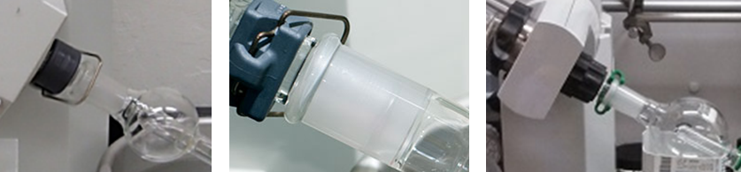
- Pre-weight a round bottom flask; fill it less than halfway with the solution to be evaporated.
- Connect the round bottom flask containing the solvent to the bump trap and secure with a Keck clip.
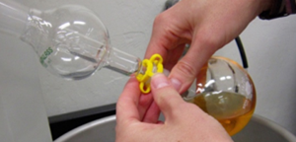
- Turn on the vacuum. You should hear a hissing sound if the stopcock on the evaporator is not closed. Slowly close the stopcock on the evaporator, once closed the sound should stop.
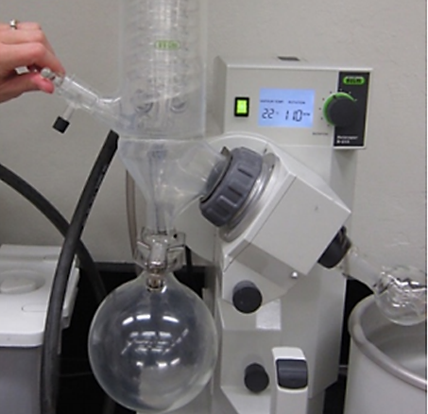
- Begin rotating the flask. Ensure that the solution does not foam or boil too much.
- Wait until the rotation and apparatus equilibrate to proper reduced pressure and speed. Keep a watchful eye on the evaporation (boiling) of the solvent (vent or change speed as needed).
- Allow the solution to evaporate. The solvent should collect in the solvent reservoir.
- Once the flask changes in temperature and becomes cool to the touch, lower the mechanism into the water bath or lift the water bath to the evaporation flask (depending on the rotovap you are using). Make sure that the solvent level is equal to the water bath level. Never put the flask so low that the Keck clip touches the water.
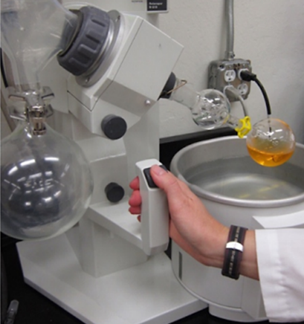
- If needed you should start to heat the water bath. [Keep in mind that the sample is under vacuum, this will lower the boiling point]
  - Never have the water bath temperature higher than the boiling point of the solvent
- Keep a watchful eye on the evaporation of the solvent.
  - If the sample is boiling too vigorously, remove it from the water bath, decrease the temperature, or change the rotation speed.
- Allow the solution to evaporate until the product has been isolated or until the desired amount of volatiles have been removed.
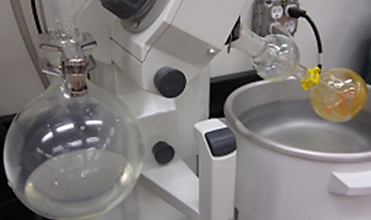
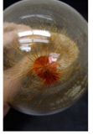
  - When the sample appears to be completely done evaporating allow the flask to remain at reduced pressure, while heating, and rotating for at least a few minutes to ensure that all of the volatiles are removed.
- Once the evaporation is complete conduct the same steps in the reverse order: turn off the hot water bath, remove the flask from the water, stop the rotation, turn off the vacuum, slowly open the stopcock to vent the system (remove residual vacuum) while holding the flask (to avoid it falling and breaking), and remove the flask.
- Make sure to empty the solvent reservoir into the appropriate waste container and clean the bump trap. Remove the water from the hot water bath when finished using the rotovap, this will prevent it from evaporating and leaving behind a residue.

Emergency procedure (if safe to do so)
- Turn off the vacuum. Vent to remove the residual vacuum.
- Turn off power.
- Unplug the electrical cord.

- Special handling procedures, transport, and storage requirements
Describe special handling and storage requirements for hazardous chemicals/gases in the laboratory, especially for highly reactive, unstable and highly flammable materials and corrosives. Describe transport and secondary containment requirement, between the laboratories or between facilities.
- Preventive Maintenance
Clean up and preventive maintenance is important for keeping equipment in safe working order. In this section, describe any regular maintenance and / or calibration frequency for research equipment, instrumentation and/or facilities.

Make sure to empty the solvent reservoir into the appropriate waste container and clean the bump trap after each use.

Remove the water from the hot water bath when finished using the rotovap, this will prevent it from evaporating and leaving behind a residue. Residues are difficult to remove and decrease the efficiency of the water bath. Also, change the water regularly to prevent the buildup of bacteria colonies.

Check greased joins on the rotovap, confirm they are properly greased to ensure a proper seal. Apply addition grease if necessary.

- Monitoring and Safety Systems
This section includes a list of all monitoring systems such as gas detectors, safety interlocks, equipment guards, fail-safe control logic, etc. noted.
- Waste Disposal/Cleanup
Describe waste handling procedures for collecting, storing, and disposing of liquid, solid, or mixed waste (including associated contaminated debris) generated in this procedure. Include container types, labeling, segregation, and any required treatments prior to disposal (e.g. neutralization or decontamination steps).
The main waste generated during rotary evaporation is residual solvents. Dispose of any hazardous waste generated through UCI EH&S. A hazardous waste pick up can be scheduled by completing a Hazardous Waste Pick up Form, via the internet, www.ehs.uci.edu/programs/enviro/ or texting hwp@uci.edu (detailed instructions can be found at https://www.ehs.uci.edu/apps/waste/Text%20a%20Chemical%20Waste%20Request.pdf or https://www.ehs.uci.edu/apps/waste/text_to_collect.jsp).
- Emergency Response Plan
In this section describe any special procedure for spills, releases or fire. Indicate how accidental events should be handled and by whom. List emergency contact numbers for laboratory personnel.
Additional emergency procedures: Describe any additional, local emergency procedures.

First Aid Procedure
If inhaled
- Move to fresh air
- Have victim rest in half-upright position
- Seek medical attention immediately
In case of skin or eye contact
- Immediately flush skin or eyes (eyewash station) with plenty of water for at least 15 minutes
- Remove contaminated clothing and shoes
- Get medical attention immediately
If swallowed
- Do not induce vomiting unless directed to do so by medical personnel and never give anything by mouth to an unconscious person.
- Loosen tight clothing such as a collar, tie, belt or waistband.
- Get medical attention immediately
Life-threatening emergencies (e.g. fire, explosion, large-scale spill or release, compressed gas leak, valve failure, etc.)
- If possible, turn off the vacuum, power, and unplug
- Evacuate the room and close the door behind you
- Secure the room to prevent entry
- Alert people in the area and activate the local alarm systems
- Call 911 – Tell the dispatcher the name of the gas or chemical.
- Report to EH&S at x46200 within 8 hours
- Complete online incident report at https://www.ehs.uci.edu/apps/hr/index.jsp
Identify the area management staff that must be contacted and include their work and home numbers. This must include the PI and may include the safety coordinator and facility manager.
In case personnel exposed or injured
- Remove the victim from the area if it is safe to do so
- Follow first aid protocol as mentioned above
- Provide safety data sheets (SDSs) for all chemicals to Emergency Medical Technician (EMT) or to the hospital
- Report to EH&S x46200
- Complete the online incident form https://www.ehs.uci.edu/apps/hr/index.jsp or Human Resources, Workers Compensation at x9152
Non-life threatening emergencies
- Notify your supervisor or faculty staff
- Report to EH&S x46200
Identify the area management staff that must be contacted and include their work and home numbers. This must include the PI and may include the safety coordinator and facility manager.
For spill & accident procedure
In the event of a small spill or release that can be cleaned by a trained local personnel follow these steps:
- Use appropriate personal protective equipment and clean up material for chemical spilled
- Double bag spill waste in clear plastic bags, label and schedule a chemical waste pick-up
In case of large spill or release:
- If possible, turn off the vacuum, power, and unplug
- Evacuate the spill area
- Post someone or mark-off hazardous area with tape and warning signs
- Call 911 and EH&S at x46200 for assistance
- Keep the fire extinguisher nearby
Note: Fire extinguishers containing water are not suitable for flammable liquid fires
Building maintenance emergencies (for example: power outage, plumbing leaks)
Submit a Facilities Service Request (https://service.fac.uci.edu/html/en/default/reportTemplate/viewPageReport.jsp ) or call appropriate building manager.

- References
This section should include the references that were used to produce this SOP.
- Miller, K. A.; Liu, D.; Braun, P. V. Rotary Evaporator Standard Operating Procedure. Lab 3724 and 3710 Beckman Institute. Materials Science and Engineering.
  - https://braungroup.beckman.illinois.edu/files/2018/02/SOP_BI-001_Rotovap-1.pdf
- How to use a rotary evaporator. UCLA.
  - http://www.chem.ucla.edu/%7Ebacher/Specialtopics/rotavap.html
- Sepos, E. Standard Operating Procedure. Rotary Evaporator in the P.O.W.E.R. Laboratory.
  - https://engineering.purdue.edu/Powerlab/Standard%20Operating%20Procedures/Rotary%20Evaporator%20(SOP).pdf
- Fisher, D.; Shepherd, N. Standard Operating Procedure Using a rotary evaporator with water aspirator or pump.
  - https://sydney.edu.au/science/molecular_bioscience/ohs/documents/sop/SOP%20SMB_050.1_Using%20a%20rotory%20evaporator%20DF%20NS%200614.pdf

- Additional Notes and Attachments
In this section list, any notes or attachments needed to implement this SOP.
- Documentation of Training
- Any deviation from this SOP requires approval from PI.
- Prior to conducting any work with the equipment, designated personnel must provide training to his/her laboratory personnel specific to the hazards and procedures involved in working with this process.
- The Principal Investigator must provide his/her laboratory personnel with a copy of this SOP and copies of any SDS provided by the manufacturer for any chemicals used.
- The Principal Investigator must ensure that his/her laboratory personnel have attended appropriate laboratory safety training or refresher training annually.

I have read and understand the content of this SOP:
Name | Signature | Identification | Date

