Standard Operating Procedure  Quenching Reactive Organometallic Reagents  Butyl Lithium | 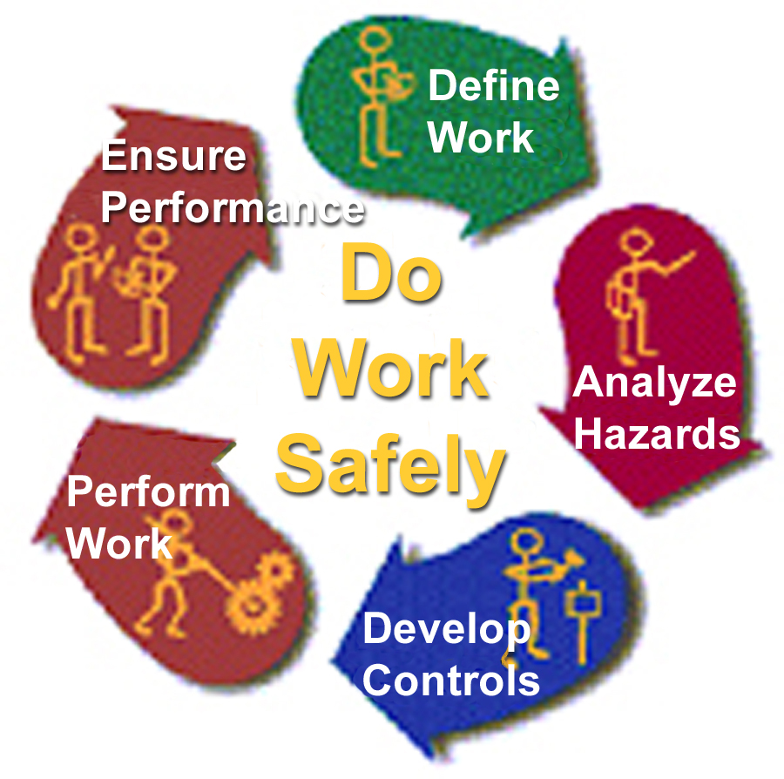

Define the Work

Description of Process

Analyze the Hazards

Hazardous Chemicals, Processes & Reactions Involved

Develop & Implement Controls

Engineering/Ventilation Controls

Special Handling Procedures and Storage Requirements

Personal Protective Equipment

Spill And Accident Procedures

Waste Disposal

Approval Required

Decontamination

Designated Area

PROCESS (see spill procedures for emergency response)
When a container with any isomer of butyl lithium becomes discolored, or develops precipitate. It is time to retire this material and start over with new reagents. It is good policy to quench these strong bases in a timely fashion so someone else will not be injured.The Procedure:
Perform the entire quenching operation under an inert atmosphere; argon or nitrogen gas
First, remove the container to a clean, clear fume hood. Acquire a container, properly labeled as hazardous waste in which to place the organic liquid components at the end of the process. Obtain a container of sufficient size to hold both ice water and the flask. Place a stir bar into the flask and charge it with an inert atmosphere.
Next, transfer the butyl lithium Erlenmeyer or round bottom flask of sufficient size to accommodate the addition of the quenching solvents. Several arrangement of glassware can be used to prevent contact with oxygen and still allow the addition of quenching solvents. Place the flask into the ice water bucket sitting on a stir plate; secure it with a clamp to prevent it from falling over. Be sure any potential path for excess pressure to rapidly escape is pointed away from any people or equipment. When quenching a significant volume of lithiate, obtain and use a blast shield.
Now, with sufficient stirring (or swirling) a small aliquot of n-butanol. If gaseous bubbles appear, stir and wait until they stop, then add another small aliquot of n-butanol. Continue this cautious step-wise addition until the generation of gaseous bubbles becomes very slow.
After the n-butanol, try adding an alcohol with more freely available protons, like isopropanol. Continue the same cautious, step- wise approach until the gas bubble generation slows considerably. Remember to stir or swirl the flask occasionally, always keeping the mouth of the flask pointed away from anyone. Once you've used isopropanol, try the same step-wise cautious addition with these solvents in sequence: ethanol, methanol and water.
Be Very Careful with the addition of WATER! Even after methanol has been added, the lithiate can still react violently with water, especially is there hasn't been sufficient mechanical stirring of the solution. So add in small aliquots.
Once the reaction with water is complete, use a suitable acid solution to neutralize the basic solution you've created. Good choices include 3 molar hydrochloric acid (3 M HCl) and citric acid, which may be easier to use. Add the acid in aliquots with the goal of obtaining a pH of 7. Don't be obsessive about this obtaining this exactly; in the 5 - 9 range is OK. Pour this solution into the aforementioned properly labeled waste container and see that it is disposed of in a safe, legal manner. In order to properly label the waste container with the percentages, you must keep track of the approximate amounts of the various solvents you used in this quenching process.

APPROVAL REQUIRED
BEFORE conducting this operation, approval from the Principal Investigator, or designated person, is REQUIRED.

HAZARDOUS CHEMICALS INVOLVED
For Chemical Safety Information visit the resources available through the University of California, Riverside; Environmental Health & Safety Material Safety Data Sheet web site at www.ehs.ucr.edu/msds

PYROPHORIC MATERIALS

Butyl Lithium compounds spontaneously ignite upon exposure to air

FLAMMABLE LIQUIDS:
The original butyl lithium reagents are generally dissolved in hexane, pentane, toluene or cyclohexane. In addition, butanol, isopropanol, ethanol and methanol are all quite flammable.

CORROSIVES:

ACIDIC SOLIDS: Citric acid

CAUSTIC SOLIDS:
Lithium compounds

ACIDIC LIQUIDS:
Hydrochloric acid

ENGINEERING/VENTILATION CONTROLS
Use a fume hood, preferably with the sash as closed as possible and a blast shield. Perform all operations in the hood, stand behind a blast shield (or the sliding sash windows – is so equipped) and reach around to perform the manipulations required.

SPECIAL HANDLING PROCEDURES and STORAGE REQUIREMENTS
Label the hazardous materials with their full name and associated hazards. (Or post the abbreviations used along with the full chemical names and hazards in a conspicuous location where ever the containers or stored or used. Store the flammables in the approved flammables storage cabinet.
Use secondary containment carriers whenever transporting hazardous material outside of the lab. Use due care and caution when moving hazardous materials around anywhere.

PERSONAL PROTECTIVE EQUIPMENT

EYE PROTECTION
Safety Glasses or Goggles
Face Shield if desired

PROTECTIVE CLOTHING
Apron or Lab coat
Gloves: neoprene, nitrile, or PVC

SPILL and ACCIDENT PROCEDURES
If one spills the unquenched material, MOVE QUICKLY AWAY. The drying agent may spontaneously ignite in the air and the flammable solvent may cause a flash fire. Inform EVERYONE in the immediate area and have them move to safe location.
If the spill is large call the hazardous materials response spill team (UCR EH&S www.ehs.ucr.edu x 85528 or 911 after hours) and inform them of the condition. There are two likely occurrences, the organometallic materials will spontaneously ignite and burn the flammable solvent. Or the organometallic material has sufficiently oxidized and only the flammable liquid will evaporate. If there is a fire, EXIT and CALL 911 to get the Fire Department (UCR PD http://police2.ucr.edu), the entire area may be quickly engulfed in flames.
If the spill is small, and doesn't contain spontaneously ignite, treat it as a flammable materials spill and 'dike' it with absorbent spill cleanup material (polypropylene pads, or absorbent materail) cover the spill with the absorbent then, once the spill is absorbed, sweep it into a bag, properly labeled with the contents for hazardous waste disposal.
If the spill evaporates completely and leaves the slowly oxidizing organometallic material behind, gather these carefully into a beaker and quench with the same previously described procedure.

WASTE DISPOSAL
Dispose of the properly labeled hazardous waste in a safe legal manner. At the University of California, Riverside contact EH&S Waste Management via the web (www.ehs.ucr.edu/programs/waste), or at (909) 787-5528. Non-hazardous waste may be placed in a container to go to a sanitary landfill or, if appropriate, washed into the sewerage system.

DECONTAMINATION
All contaminated personal protective equipment and glassware used should be washed with soap (or detergent) and water.

DESIGNATED AREA
The operation should ONLY BE CONDUCTED in a CLEAN, Properly Operating FUME HOOD or GLOVE BOX. DO NOT perform this process ALONE! Have an informed, prepared person be in the area.
Created by:
Russell Vernon, Ph.D.
Laboratory & Research Safety Specialist
Environmental Health & Safety
University of California, Riverside
Riverside, California 92521
Direct (909) 787-5119
Admin 787-5528; Fax 787-5122
russell.vernon@ucr.edu
http://www.ehs.ucr.edu

Last updated: Friday, September 19, 2003 www.ehs.ucr.edu/programs/lab

These safety training resources, prepared solely for the use of the Regents of the University of California, were provided by a variety of sources. It is your responsibility to customize the information to match your specific operations. Neither the University of California nor any of its employees, makes any warranty, express or implied, or assumes any legal liability or responsibility for the accuracy, completeness, or usefulness of any information, or represents that its use would not infringe privately owned rights. Reference herein to any specific commercial product, process, or service by trade name, trademark, manufacturer, or otherwise, does not necessarily constitute or imply its endorsement, recommendation, or favoring by the University of California. The views and opinions of authors expressed herein do not necessarily state or reflect those of the University of California, and shall not be used for advertising or product endorsement purposes.

