Solvent Dispensing System Manual

Designed by
J. C. Meyer

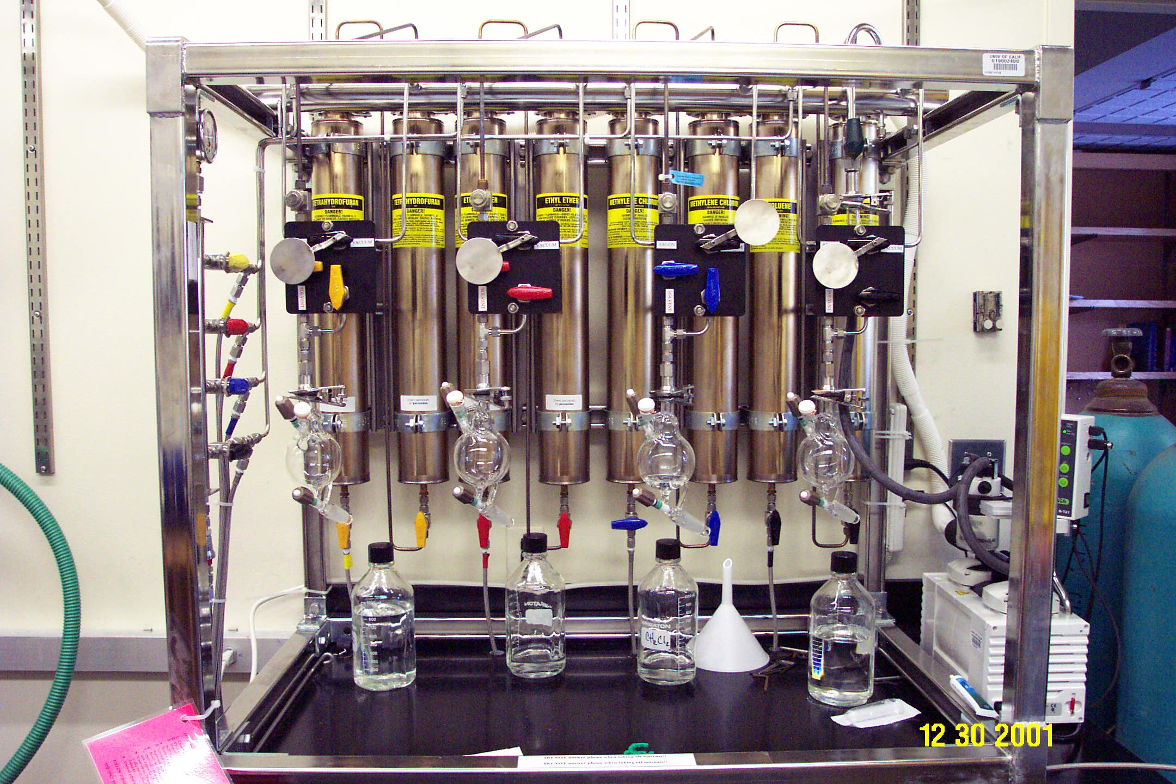

Table of Contents

I. Introduction...............................................................................3

II. Inert Gas Supply......................................................................3
Tanks
Regulators
Over Pressurization
Additional Nitrogen Manifold

III. Solvent Kegs...........................................................................5
Solvent Types
Replacing Kegs
Degassing Kegs

IV. Columns.................................................................................7
Components
Packing

V. Vacuum System......................................................................8
Vacuum Pump
Emptying Solvent Trap

VI. Control Valves......................................................................10
Vac/Ar Valve
Control Valves A, B, and C

VII. Dispensing Solvents............................................................11
Steps for Solvent Delivery
Routine Use of Solvent Bulbs

VIII. Trouble Shooting...............................................................15

Credits

Design and Construction of System.............................................J. C. Meyer

Manual Preparation......................................................................Helen E. Blackwell

Matthew E. Hart
I. Introduction

This manual gives a basic overview of the Solvent Dispensing System (SDS) to give the user a basic knowledge of the apparatus, and to explain some of its necessary operations. Since one (or more) group member(s) is (are) specifically assigned to take care of the instrument, this manual is meant to assist individuals in the absence of the specified group member(s).
The SDS incorporates a high vacuum pump and an Argon supply, and can be used to deliver dried, degassed solvent under a blanket of Argon. The basics of its operation are as follows: (1) an oven-dried, solvent recovery flask is subjected to several vacuum “pump-down”/Argon “back-fill” cycles on the SDS, and finally left under vacuum. (2) The solvent is drawn through the drying columns by this static vacuum, while being simultaneously pushed with a positive pressure of Argon out of the solvent kegs, and collected in the recovery flask. (3) The flask is then either sealed and removed from the solvent system for personal use, or the flask can remain attached to the SDS and be used by a group, in similar fashion to a collection bulb on a solvent still.
What follows is an explanation of the different parts of the SDS, including the Argon supply, solvent kegs, columns, vacuum system, and solvent delivery controls. A short procedure has also been prepared that explains how to dispense the solvent. Anyone using the SDS should be familiar with this procedure.

II. Inert Gas Supply

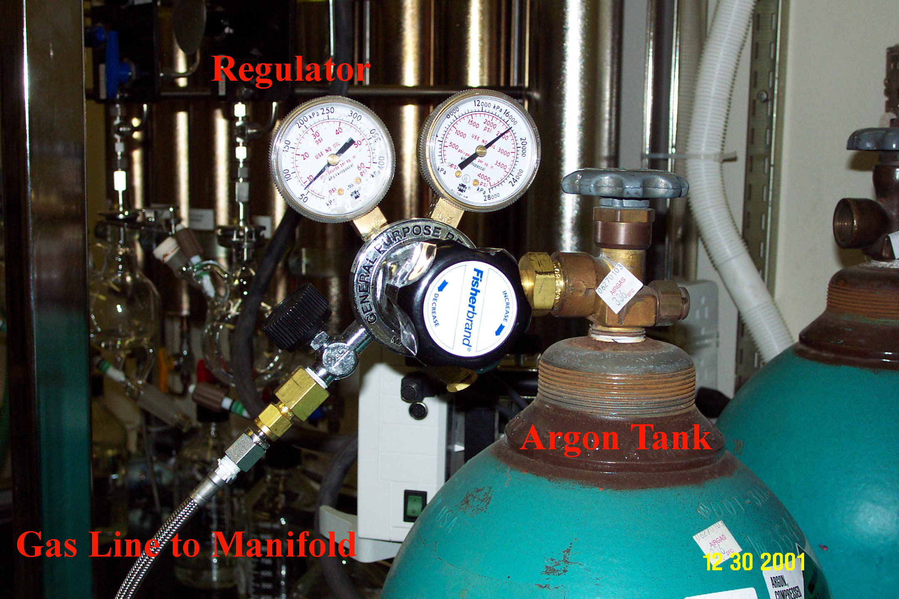
The SDS has an ultra-high purity Argon supply to keep the solvent kegs, columns, and recovery flasks under an inert gas atmosphere. When the Argon tank is connected to the system, the regulator on the tank should be set between 5-8 psi. (Note: some gas regulators have a tendency to slowly increase in pressure over time. Be sure to check the pressure on this gauge periodically. Please notify the SDS manager(s) immediately if the tank is nearing empty (at or below 500 psi) or if a leak is suspected. Under normal operating conditions, an Argon tank should last for approx-imately 4-6 weeks.
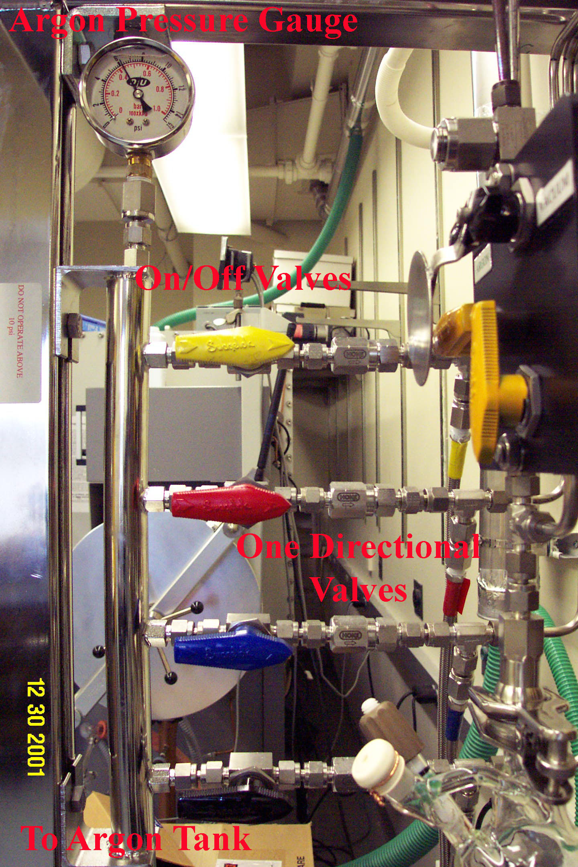
Argon is introduced into the SDS system through a SST hose which connects through a green on/off Swagelok® valve. After this valve, the Argon line is split into separate Argon lines, one for each column. Argon flow to the lines is controlled through individual color-coded/on/off Swagelok® valves. All of the valves controlling each solvent (on the Argon manifold, columns, and dispensing outlets) are uniquely color-coded (see below). After the on/off valves, each Argon line is equipped with a one-way, Nupro® flow regulator, which prevents Argon back flow from the different solvent kegs to mix and cross-contaminate each other. Each Argon line is then split in turn, with one line going to the solvent keg, and another line going to the solvent dispensing outlet. A pressure gauge is present on the SDS Argon manifold. This gauge should read 5-10 psi.

Over Pressurization
In the event that the system does begin to over-pressurize with Argon uncontrollably, the stainless steel tubing is rated not to rupture up to high pressures (~800+ psi). However, a pressure release valve with a threshold of 50 psi is present directly at the inlet from the Argon tank to the Argon manifold (covered with a blue plastic cap), and back-up pressure release valves (threshold 60 psi) are present on each solvent keg (covered with blue plastic caps).

III. Solvent Kegs
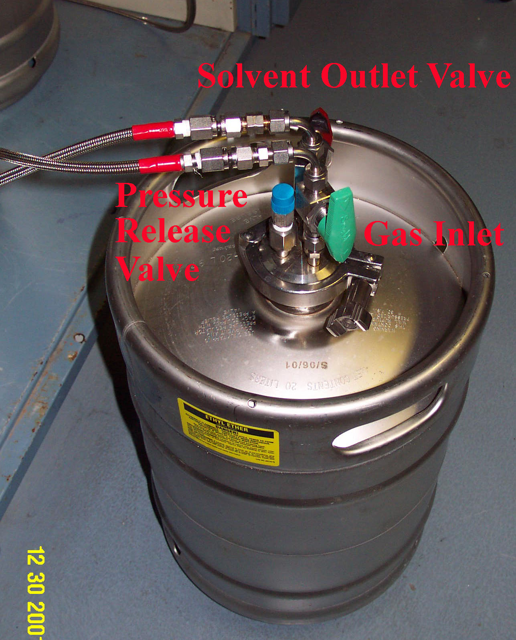
Each keg’s main Argon inlet is green and solvent delivery outlet is color coded as to which solvent it corresponds.
There are two control valves on each keg: one is the Argon inlet and the other is the solvent outlet (under normal working conditions). The Argon inlet is a green on/off valve, while the solvent outlet allows flow in two different directions. As stated above, the solvent kegs have a pressure release valve (covered by blue plastic cap) with a threshold of 60 psi. This ensures that the system does not become over-pressurized.

Replacing and Degassing Solvent Kegs:
When the volume of any keg has been reduced to 7 liters, new solvent should be ordered immediately. Please notify a group member in charge of the SDS at this time. When the volume of the keg has been reduced to approximately 5 liters, STOP using the keg, and notify the SDS manager (The SDS managers will take over at this point). Close both the Argon inlet and the solvent outlet on the empty keg. Isolate the solvent columns from the keg under Argon by closing the solvent column inlet and outlet valves. Finally, close the Argon inlet to the keg at the SDS Argon manifold. Disconnect both the Argon and solvent lines to the keg, quickly sealing the solvent line with a small septa to prevent air from entering the line (Make SURE the solvent column inlet valve is closed AND a septa is placed at the end of the solvent line to prevent draining all of the solvent out of the column, introducing air into the column, and drying out the solvent packing!!).
If prepackaged solvents are being used, the solvent has NOT been degassed when they arrive, and the column packing DOES NOT adequately degas the solvent. Therefore, before a fresh keg of solvent is attached to the SDS, it is important to purge the solvent with Argon in order to degas it. To do this, the Argon line is attached to the closed solvent outlet on the keg. An additional teflon purge line is then attached to the original, closed Argon inlet and vented into the hood adjacent to the SDS. This additional teflon purge line should be stored in the vicinity of the SDS. (NOTE: the directionality of the Argon inlet and solvent outlet have been reversed-Argon will be introduced through the solvent outlet valve, and exit out of the Argon inlet valve. This method takes advantage of the long “dip tube” in the keg to which the solvent outlet is attached, allowing Argon to bubble through the entire volume of solvent in the keg. Under normal operation, this “dip tube” facilitates efficient delivery of solvent from the keg, and also provides access for the digital volume gauge.)
The pressure of Argon should be approximately 5-8 psi. The Argon supply is turned on, both the inlet and outlet valves on the keg are opened, and the solvent is purged for 30 minutes (The Argon passing down through the “dip tube” and bubbling up through the solvent can be felt physically through the keg). Then, both the inlet and outlet valves are closed, the Argon supply is turned off, and the solvent is allowed to equilibrate for 5 minutes. This purging procedure is repeated one more time for 15 minutes. Once the second purge is complete (and both inlet and outlet valves have been shut), the Argon inlet tube is reattached to its original position (the Argon flow remains on to purge the line), the stainless flex-tubing is quickly reattached to the solvent outlet, and the valves are turned to the standard operating positions.

IV. Columns

The columns used in the SDS are intended to vigorously dry the solvents. THF, diethyl ether, acetonitrile, and methylene chloride are passed through two packed columns of neutral alumina. In the cases of hexane, benzene, and toluene, one of the columns is alumina and the other is Q5 reactant, a copper(II) oxide oxygen scavenger (similar to dry box catalyst). DMF is dried simply by passage over two columns of activated molecular sieves. All of the solvents are passed through an in-line, 2 micron filter immediately before being dispensed. The 2 micron filter ensures that no packing material residue is dispensed with the solvent. The filters used by the SDS are Nupro® TF series Tee-type sintered filters. Over time, these filters can become clogged with particulate, and need to be cleaned or replaced. Clogged filters can be sonicated to loosen the filtered material. Sonicate in appropriate solvent and blow dry against direction of arrow.
The solvent column inlet valve should be turned off when a solvent is not going to be used for a while (1 week and longer). In the case of methylene chloride, the solvent column inlet valve should be turned off if the solvent has not been used in 2-3 days. This avoids the chance of back siphoning the solvent from the column into the solvent keg due to the methylene chloride’s specific gravity.

V. Vacuum System

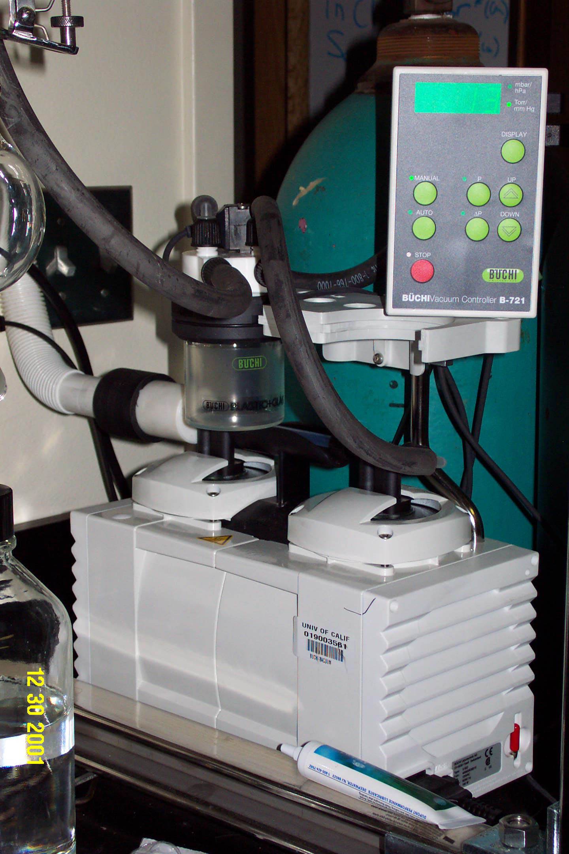
The vacuum system of the SDS is a crucial component to proper operation. It is important that the vacuum is running efficiently. A traditional vacuum system consists of the vacuum pump, solvent trap, and the vacuum manifold. The latest systems operate using a Buchi oil-free diaphragm pump, with or without a controller (see picture). It is important to be able to locate the main vacuum on/off valve, the vacuum release valve, the vacuum gauge, and the in-line on/off switch between the vacuum pump and the trap.
The vacuum Dewar surrounding the solvent trap must be filled with liquid Nitrogen everyday. This is the job of the SDS managers. The volume of liquid Nitrogen should be at or around the marked fill line on the Dewar (Filling the trap higher than the marked fill line with liquid Nitrogen could result in clogging the trap with a frozen plug of solvent, and preventing the pump from evacuating the SDS). If the SDS is not maintained daily, the in-line on/off switch between the pump and the trap should be turned off, the vacuum vented, and the solvent trap emptied (see method below). This ensures that little or no solvent is sucked into the pump oil, dramatically extending the lifetime of the pump and the time between pump oil changes. Under standard operating conditions, the vacuum gauge should read at or under 10 milliTorr of pressure. If the pressure is significantly higher than this value, it is likely that the solvent trap must be emptied (see below). The pump oil should also be checked for contamination at this time. If the pressure is significantly high even after the solvent trap is emptied and reinstalled, a SDS manager should be notified.
To avoid the chronic need for trap filling and possible condensation of oxygen, the latest SDS’s use a Buchi oil-free pump. This eliminates potential fire hazards if the solvent is accidently pulled through the pump. These pumps normally pump down to 8 Torr. The manual pump is turned on when the system is being used. The pump with a controller automatically turns the pump on /off to maintain a preset vacuum.

Emptying the Solvent Trap
To empty the solvent trap, the main vacuum on/off valve is shut (leaving the SDS vacuum manifold under static vacuum), the in-line on/off switch between the pump and the trap is shut (isolating the pump from the trap), and the vacuum release valve is opened (do these three operations in this order). The two Thomas clamps holding the solvent trap to the system are removed, and the trap is carefully removed from the dewar. After the solvent melts, the trap is emptied, cleaned out with acetone and/or methylene chloride, and completely dried. The trap is then carefully placed back into the dewar and clamped into position. [Care must be taken not to over tighten the Thomas clamps, which can result in cracking the glass ball-and-socket joints. Minimal Krytox® grease should be applied if necessary to obtain a tight seal.] Then, the vacuum release valve is closed, the in-line on/off switch between the pump and the trap is opened (pumping down the trap), and finally, the main vacuum on/off valve is opened (pumping down the entire SDS vacuum manifold). Check the vacuum gauge to make sure it reads at or under 10 milliTorr of pressure. Fill the dewar up to the marked fill line with liquid Nitrogen.

VI. Control Valves

The solvent delivery controls consist of a vacuum/argon valve, a vacuum/argon on/off valve (valve B), and a solvent delivery valve (valve A). Valve B controls the application of a vacuum or Argon pressure into the solvent recovery vessel, which is dictated by the Vac/Ar valve. The Vac/Ar valve is switched between the Argon supply, to the left, and the vacuum line, to the right. Under standby conditions, Valve A and B are closed and the Vac/Ar valve is set to vacuum. All of the 8 solvent delivery controls are identical, except for the DMF delivery controls. Due to the high boiling point of DMF, residual DMF in the solvent delivery line can not be adequately removed by the pump. Therefore, an additional valve (Valve C) has been installed directly above the DMF solvent delivery outlet to allow sufficient purging of the solvent line with Argon after solvent delivery (see below).
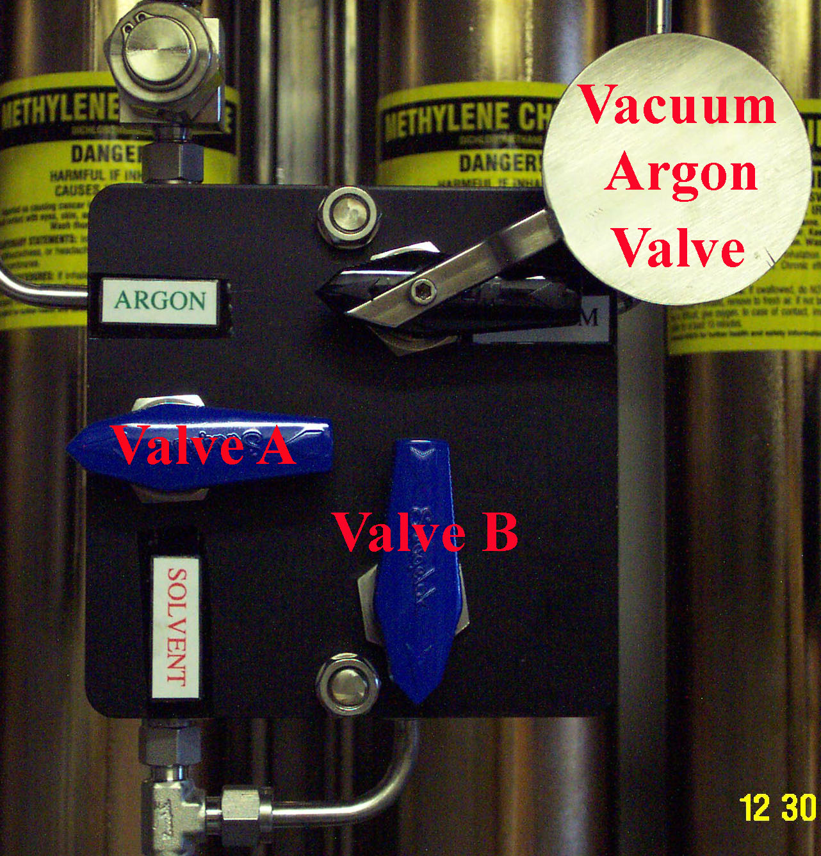

NOTE: Never have valve A and B open at the same time when the Vac/Ar valve is set to the vacuum!! This will cause the solvent to be sucked out of the column, into the solvent trap, and eventually into the pump. This is the most important warning to note! The metal disk installed on the Vac/Ar valve was designed into the system to prevent this happening: when the Vac/Ar valve is switched to vacuum, this disk covers Valve A and inhibits its turning. Remember, always draw solvent into the recovery flask using STATIC vacuum, not DYNAMIC vacuum.

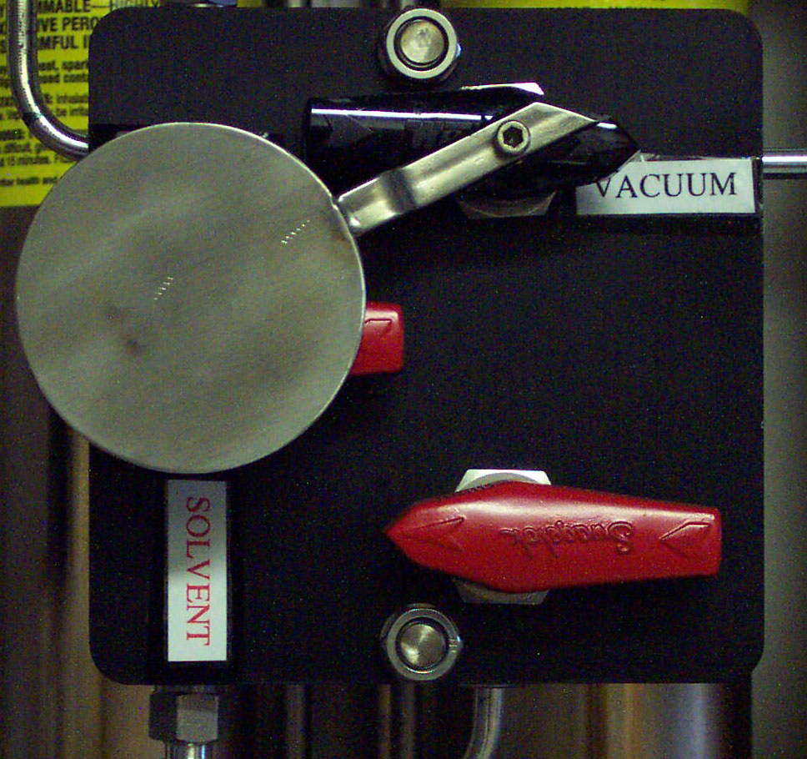
VII. Dispensing Solvents

This section describes the general procedure for dispensing solvents. It highlights some precautions to take before using the SDS. Everyone that uses the SDS should understand this section completely. If you still do not feel comfortable using the system, ask someone to help you.

Before collecting solvents, check the following system settings:
- The vacuum pump is operating and maintaining adequate vacuum. Check that the vacuum gauge reads at or around 10 milliTorr.
- The dewar is filled with liquid Nitrogen up to the marked fill line.
- The Argon tank has sufficient Argon for use, and the Argon is flowing.
-Check tank regulator and SDS pressure gauge (should read 5-8 psi)
4) Check column and solvent keg valves.
-All valves should be open to the solvent keg and on the solvent column from which you wish to dispense (Argon inlet valve on Argon manifold, keg Argon inlet valve, keg solvent outlet valve, and the 4 valves on the solvent column). These all should be left open for routine use.

Identification of valves:

Vac/Ar Valve: Used to switch between the vacuum manifold and the Argon manifold. This is an on/off Swagelok® valve.
Valve A: Used for the addition of solvent into the receiving flask. This is a color-coded on/off Swagelok® valve.
Valve B: Used to apply the vacuum or Argon pressure, as dictated by the Vac/Ar valve. This is a color-coded on/off Swagelok® valve.
Valve C: Used to additionally purge the solvent delivery line for the DMF column with Argon. This is an on/off Swagelok® valve.

Precautions to take:
Never open valves A and B when the vacuum is open.
Never use recovery flasks with star cracks or other defects!
Steps for solvent delivery:
1) The solvent delivery outlet should be maintained under vacuum, with valve A closed, valve B closed and the Vac/Ar valve set to the vacuum position (See I). IMPORTANT: Inspect your recovery flask, and make sure it has no star-cracks or defects-these could cause the flask to implode/explode when placed under vacuum/Argon pressure.

2) Remove the Thomas clamp and the empty flask. Clamp on the appropriate oven-dried, clean adapter and receiving flask, securing the flask to the adapter with a green Keck® clip. Make sure that the Thomas clamp between the adapter and the outlet is NOT tightened AT ALL-this loose connection ensures there is an OUT upon back-filling with Argon. Open valve B to apply vacuum to the flask (See II).

3) The receiving flask now needs to be evacuated with vacuum and back-filled with Argon several times. To achieve this, an adequate vacuum must be maintained on the flask (approx. 100 milliTorr). Then the Vac/Ar valve is turned to Argon while valve B remains open to fill the flask with Argon (See III). Next, the Vac/Ar valve is returned to the vacuum position and an adequate vacuum is pulled (approx. 100 milliTorr) (See IV). Repeat this pump-down/back-fill procedure 4 times. IMPORTANT: If you are filling a standard SDS solvent bulb, quickly open and close the stop cock to the 14/20 female joint (covered with a septum) in the middle of the Argon back-fill cycles to purge this port. Do NOT pump down on the inlet, as the septa are not air-tight!! Leave this port under Argon at the end, and close the stop cock. End with the recovery flask under vacuum.

4) Now the flask is ready to receive solvent. With the Vac/Ar valve set to vacuum, valve B is closed (See V). This leaves the recovery flask under STATIC vacuum. Then, the Vac/Ar valve is turned to Argon (See IV).

5) To dispense the solvent into the receiving flask, open valve A. If solvent DOES NOT flow or only dribbles out, STOP, and close valve A. Check the valves on the column, keg, and Argon line, and make sure that they are all open. Make sure valve B is closed and the Vac/Ar valve is set to Argon. If solvent is still not dispensed, consult the SDS manager(s). Note: Never open valve A while valve B is open and the Vac/Ar valve is set to vacuum! This will suck solvent directly out of the column and into the pump.

5) When you are finished dispensing the solvent, close valve A. HOLD ONTO THE RECEIVING FLASK and carefully open valve B (IX). The Argon will blow the solvent remaining in the line into your flask and fill the flask with a blanket of Argon (5-8 psi). [If you are dispensing DMF, open valve C above the DMF solvent delivery outlet, purge the solvent delivery line for a 2 MINUTES, and close the valve.] Next, close valve B (X) and tighten the Thomas clamp to the adapter to prevent entry of air into the flask.

6) If you are filling the standard SDS solvent bulb for group use, proceed to step (7). If you are going to remove the flask for your own personal use, either seal the flask while it is attached to the SDS system (if it has the requisite teflon/glass stopcock) and remove the flask from the SDS, or just remove the receiving flask and cap immediately. The former is the more rigorously air-free procedure. Replace the adapter with the standby flask, and reattach the Thomas clamp (only finger tight!).

Routine use of solvent bulbs:

Solvent can be removed from the SDS solvent bulbs using the analogous procedure we use to remove solvent from still solvent bulbs. Here are some guidelines and instructions:

- Make sure that the volume of solvent in the bulb will meet your needs. If not, dispense more solvent into a clean, oven-dried solvent bulb (see guidelines above). [Clean bulbs and adapters are stored in the oven adjacent to the SDS. Use clean stopcocks and new septa.
- Always use a clean, oven-dried syringe needle.
- The teflon stop cock should be open already to allow the Nitrogen line cannula into the bulb. Insert the needle through the septum and into the inlet.
- Purge the needle with the Argon/Nitrogen gas in the solvent bulb (3-4 times). HOLDING onto the solvent bulb, push the needle through the stop cock opening and into the bulb. Open the stop cock further if required to get your needle into the bulb. Remove the volume of solvent you want. DO NOT inject any solvent back into the bulb once you have removed it.
- HOLDING the bulb, remove the needle from the bulb. Readjust the stop cock if you opened it further.
- Larger volumes of solvent can also be removed using the additional outlet at the bottom of bulbs. Simply open the teflon stopcock and dispense solvent. Please wipe up any spills you might have in the delivery process.
- Out of courtesy for your co-workers, if you empty a bulb of a frequently used solvent, please clean the used bulb, return it to the oven adjacent to the SDS, and refill a fresh solvent bulb. Don't just leave the empty bulb on the SDS for someone else to clean and refill!

VIII. Trouble Shooting

This section is a growing section where Jorg has included information about common problems associated with the daily use of the SDS. It will be as complete as possible. Jorge will consult other labs with the same system for additional potential problems. If you would like to add items to this list, please let the SDS managers know. A trouble-shooting notebook will be kept near the SDS for group members to record problems they have with the instrument. Please make use of this notebook so we can maintain an up-to-date operational history of the system.

1) Maintain the Argon regulator and service the vacuum pump, if using a conventional pump. Most importantly, change the pump oil regularly.
2) Use the proper grade of solvent in the solvent kegs. Stabilized solvents should NEVER be used because the column packing material does not adequately remove the stabilizer.
3) If solvent only dribbles out or doesn’t flow, and all the valves are open and the kegs are full, it is likely the filters need cleaning or replacement.
4) If Buchi pump vacuum degrades read instruction manual for proper remedy. The pump may need to be cleaned by spraying acetone into intake port and allowing pump to pump itself dry

These safety training resources, prepared solely for the use of the Regents of the University of California, were provided by a variety of sources. It is your responsibility to customize the information to match your specific operations. Neither the University of California nor any of its employees, makes any warranty, express or implied, or assumes any legal liability or responsibility for the accuracy, completeness, or usefulness of any information, or represents that its use would not infringe privately owned rights. Reference herein to any specific commercial product, process, or service by trade name, trademark, manufacturer, or otherwise, does not necessarily constitute or imply its endorsement, recommendation, or favoring by the University of California. The views and opinions of authors expressed herein do not necessarily state or reflect those of the University of California, and shall not be used for advertising or product endorsement purposes.

